Lead Scoring Assignment – Subjective

**Question-1: Which are the top three variables in your model which contribute most towards the probability of a lead getting converted?**

Following are the top three variables which contributes most towards the probability of lead getting converted:

1. Tags
2. Lead Source
3. Lead Origin

**Question-2: What are the top 3 categorical/dummy variables in the model which should be focused the most on in order to increase the probability of lead conversion?**

Following are the top three categorical/dummy variables in the model which should be focused the most on in order to increase the probability of lead conversion:

1. Tags_Switched Off
2. Tags_Not doing further education
3. Tags_Already a Student

**Question-3: X Education has a period of 2 months every year during which they hire some interns. The sales team, in particular, has around 10 interns allotted to them. So during this phase, they wish to make the lead conversion more aggressive. So they want almost all of the potential leads (i.e. the customers who have been predicted as 1 by the model) to be converted and hence, want to make phone calls to as much of such people as possible. Suggest a good strategy they should employ at this stage.**

Since we not want to miss any of the potential leads, we want a model higher **sensitivity/recall.** For this we can choose cut-off which offers higher sensitivity, in our case it can be between 0.1 to 0.5. Therefore, strategy for the sales team should be to make calls to all the leads with leads_score with greater than 50.

Highlighted in the below image is our cut-off for higher sensitivity.

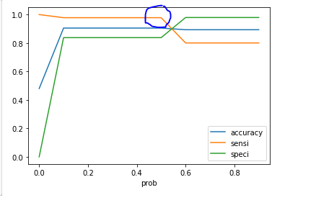

**Question-4: Similarly, at times, the company reaches its target for a quarter before the deadline. During this time, the company wants the sales team to focus on some new work as well. So during this time, the company’s aim is to not make phone calls unless it’s extremely necessary, i.e. they want to minimize the rate of useless phone calls. Suggest a strategy they should employ at this stage.**

Since we not want to not make any unnecessary calls, we want a model higher **precision.** For this we can choose cut-off which offers higher precision, in our case it can be around 0.71. With 0.71 as cut-off, we get a precision of 0.97. Therefore, strategy for the sales team should be to make calls to only the leads with leads_score with greater than 71.

Junction of precision-recall in below image is around 0.71.

